COP 17 TARGET 3 ACTION DAY MARKETPLACE  STATION NAME: Connectivity and Transboundary Conservation | 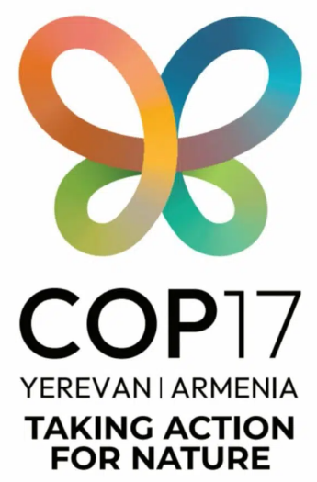

Key Messages

01  Target 3 calls for protected areas and OECMs to be well-connected and integrated into wider landscapes and seascapes. |  | 02  Ecological corridors and networks keep isolated sites functioning as a system, supporting species dispersal, migration and climate adaptation rather than leaving PCAs as fragmented islands. |  | 03  This work is often transboundary in nature; migratory species, flyways, free-flowing rivers and marine corridors cross jurisdictions and can only be secured through cooperation among countries.

Resources

IUCN’s Guidelines for conserving connectivity through ecological networks and corridors
IUCN’s Transboundary conservation: a systematic and integrated approach
Marine connectivity rules of thumb
Learn more from the IUCN-WCPA Connectivity Conservation Specialist Group (CCSG)
NEW from the GLOBAL PARTNERSHIP ON ECOLOGICAL CONNECTIVITY!
Connecting Nature to Sustain Life: A Guide to Action (including sector-specific guidance)

Center for Large Landscape Conservation

Get in Touch! | Gabriel Oppler Aaron Laur  gabe@largelandscapes.org aaronlaur@largelandscapes.org  For more information: https://www.30x30.solutions/

