COP 17 TARGET 3 ACTION DAY MARKETPLACE  STATION NAME: Effectiveness of PCAs | 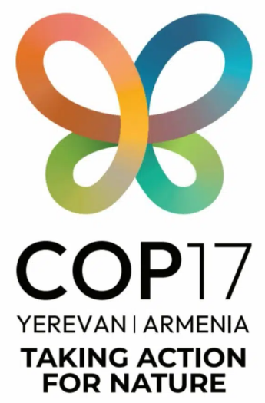

Key Messages

01  Target 3 requires not only expanded coverage of protected and conserved areas, but also demonstrably effective conservation of biodiversity and associated values. |  | 02  Build on existing PCA effectiveness assessment frameworks, strengthen their focus on outcomes, and use the new IUCN Global Standard as a benchmark. |  | 03  Systematically integrate effectiveness assessment into adaptive management of individual PCAs and national systems, using findings to guide decisions, actions and resource allocation.

Resources

- IUCN (2026). IUCN Global Standard for Effective and Equitable Protected and Conserved Areas.[URL]
- Salafsky et al. (2026). Improving Outcome-Based Effectiveness Assessments of Protected and Conserved Areas. IUCN WCPA Issues Paper 9.[URL]
- UNEP-WCMC (2025). GD-PAME User Manual, Version 2.0: Guidance on Reporting Effectiveness Data to Protected Planet.[URL]
- Hockings et al. (2006). Evaluating Effectiveness: A Framework for Assessing Management Effectiveness of Protected Areas. IUCN.[URL]
- WWF International. METT Handbook. A Guide to Using the Management Effectiveness Tracking Tool (METT) Second edition / METT-4. [URL]
- Conservation Measures Partnership (2020). Open Standards for the Practice of Conservation, Version 4.0.[URL]

Get in Touch! | Tobias Garstecki (WCPA & Re:wild) | tgarstecki@rewild.org  Paola Mejía Cortez (WCPA & Foundations of Success) | paola@fosonline.org  For more information: https://www.30x30.solutions/

