COP 17 TARGET 3 ACTION DAY MARKETPLACE  STATION NAME: Ranger and Conservation Workforce | 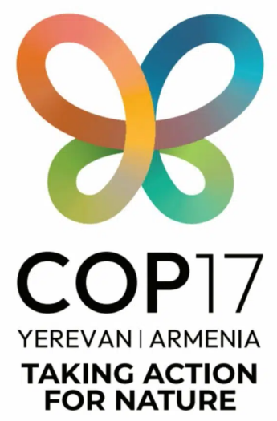

Key Messages

01  We need 1.2 million more rangers to reach Target 3. Yet, the CBD framework mentions area 300x more often than it talks about the people needed to protect it. Less than half of NBSAPs are integrating rangers into future planning. Global health frameworks mention health workers 130x more often than the CBD mentions its main workforce.  We cannot reach Target 3 with this blindspot. |  | 02  We need to center rangers in global environmental governance:  - Rangers codified into NBSAP requirements (with targets on numbers, training and conditions)  - Rangers embedded into the PoWPA  - More rangers invited, supported and funded to attend and speak at COP  - Rangers must be seen as a tool for PCA effectiveness and not a nice to have |  | 03  Ministries: Don’t wait for global guidance: start to embed rangers in your own NBSAPs now.  Donors: more joined up thinking, help fund long-term ranger solutions including training, equipment.  iNGOs: Join URSA and work with other iNGOs to support rangers globally with clear global standards  Corporates: Use sustainability and CSR programs to support ranger recruitment, training and wellbeing.

Resources

- Ranger Professionalization Toolbox Notes on Competences
- Ranger Professionalization Toolbox Notes on Conditions
- Ranger Professionalization Toolbox Notes on Conduct
- IUCN WCPA Good Practice Guide on Building trust between rangers and communities
- Rangers for 30x30
- IRF URSA Ranger Assurance Checklist
- Building Trust with Rangers and Communities (Vol-1)
- Building Trust with Rangers and Communities (Vol-2)
- Safeguarding the Rights and Well-being of Rangers (Part-1)
- Safeguarding the Rights and Well-being of Rangers (Part-2)
Get in Touch! | Hannah L. Timmins  han@equilibriumresearch.com  For more information: www.ursa4rangers.org/documents

